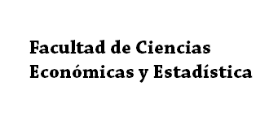

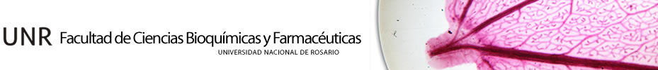

EFFICTRON

RESISTIVE MECHANOPNEUMATIC EXOSKELETON

Members:

CASTRO, Oscar Raúl Andrés.

LEÓN, Juan Emilio.

Published: 04/24/2016

Index (ctrl + Click to re-directed)

Introduction 4

The problem 5

Didactic analogy 5

Does the body malfunctioning? 6

Current solutions 9

ARED 9

CEVIS 10

COLBERT 10

Effictron 12

3 technologies: 13

The 1st Technology: Concentric rings of rubber. 13

The 2nd Technology: Compression bone. 13

The 3rd Technology: Atmospheric pressure. 14

Analysis of technologies: The Secret of the Void. 15

Technology implementation in the exoskeleton 18

Upper-Part 18

SOWT analysis 19

Strengths 20

Opportunities 20

Weaknesses 20

Threats 20

Using Effictron, a glimpse into the economy. 21

Effictron humanitarian sense. 21

Placing Effictron 22

Extra 22

Soleus 23

Hamstrings and quadriceps 23

Adductors 23

Lower back 24

Abdominals 24

Trapeze 24

Pushups 25

Biceps 25

Back 25

Triceps 26

Twins 26

Rest of the muscles 26

Planning and the future projects. 27

Enhancements of the own exoskeleton 27

Full mesh body for exercise 27

Fabrics "smart" at the service of human health 28

Supplementation with other challenges 29

Bibliography: 31

**To reader: with a pc of 1080 lines it recommends to see the file in 120% zoom**

**With lower-resolution pc´s, down zoom until bigger titles seen in a pleasant size (you can do this just pressing Ctrl + mousse wheel).**

**Remember the SOWT section as a resume of the project.**

# Introduction

*"We believe that large projects can be done with few resources and a lot of imagination. We would like to show the world that you don’t need to be an expert to direct a project; and we can see clearly both in this simple opportunity, as in many of the inventions developed by emerged countries, such are most developments of Africa, India etc…*

*Our humble contribution vulgarly call "Fierro efectivo" because that is what simply is. Its simplicity makes it developable with few resources, but at the same time not fails in its purpose. It is clear that its possible development will become a complex, computerized, full of sensors and actuators, and highly mechanized product, but as a future consequence and with the memory of having been ever thought of a couple of people who dared to enter the world of science without falling into the fallacy of thinking that this is only for connoisseurs geniuses. Faithfully I believe that knowledge must come to one while doing science, but not a lifetime preparing to start creating."*

After this introduction, we present our project:

EFFICTRON

*"The resistive mechanical-pneumatic Exoskeleton"*

# The problem

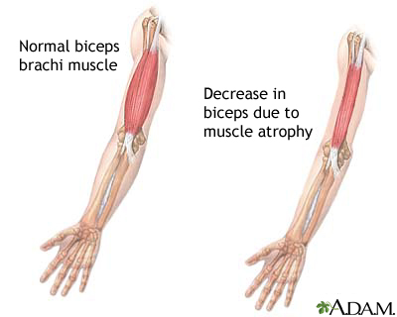The issues presented by NASA and interest we have since described the harmful effects that exist in outer space, more precisely in the International Space Station (ISS). These losses fall on the astronauts who, in the absence of a force that keeps weight on earth, his bones and muscles begin to atrophy and wear respectively. This happens because of the way our body is self-regulating. To understand this we go to analogy:

## Didactic analogy

We've all probably tried (and some succeeded) to do some workout plan and food to reduce our percentage of body fat. Some people careful maintenance of our muscles and others ignoring this issue.

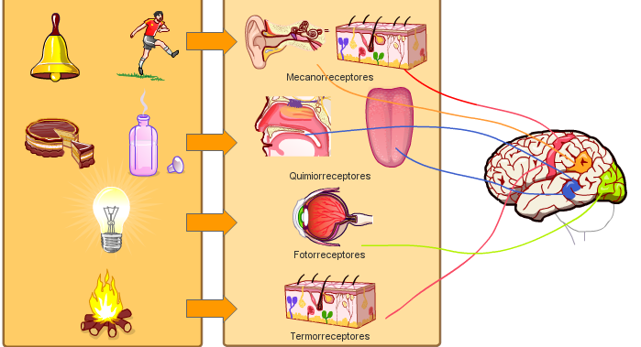To reduce this fat layer that makes us see lower socio-culturally, we exercise and follow a **diet** **plan**. In some cases, we fall into the fallacy of believing that the less you eat, the better we're doing. If it were so easy, nutritionists would not be 5 years studying how to make people lose weight. Overall, a good diet for this purpose is that reduced calorie but both strategically provide **incentives** to trick the body. These stimuli are called by the scope of bodybuilding (experts in reducing fat and increasing muscle mass) as "cheat meals". Its **main use** is not to fall into psychological traps than makes our mind when we are a necessity. For example: When we are filled with the body does not want more food, that's when we are more motivated to start a diet, right after eating. However when we carry a few days of diet and noticed the calorie deficit and especially carbohydrates that provide us the main source of energy, one begins to talk about yourself in your mind and things question like: what if all this me It is doing wrong? Am I not losing muscle with so little food? Do I really need this? And if we are not strong enough psychologically we relent and abandon the diet. Why I emphasize at the beginning of paragraph *"we do socio-culturally see below"*? Because it really is so. It is not healthy to have the six-pack at one end and have little body fat percentage level. The body rejects all these measures and that forces us to abandon our diet. The body is very intelligent, wants us to have fat reserves to survive in this situation we call diet, which we do know that is totally controlled, but the body does not know and interprets that are having a hard time getting food. Automatically an **emergency system** where heart rate is reduced is activated, it decreases the consumption of fat reserves (used as energy) consumption increases muscle mass, which has an expense of high maintenance, increases the heaviness to not make moves and burn calories, and remain in this state until "we are rescued" or nourish us.

That is the secret of a good diet: The second use of the aforementioned stimuli. These high usually weekly doses of food with lots of calories, saturated fat and flavor make our body does not believe that we are in an emergency situation, no emergency systems are activated and let burn these reserves of adipose fat to us socially see better.

This is how the human body works dramatically in virtually all sub-systems of self-regulation. And with this simple example we turn to the reality of our problem: Why the body atrophies in the absence of gravity? Is the body silly or malfunctioning?

## Does the body malfunctioning?

Definitely the body is neither stupid, nor is malfunctioning (as all astronauts suffer from muscle atrophy and bone decalcification) so we wonder what is the reason why these phenomena occur?

The current theory talks about the following: How good self-regulating and economist that is the human body, we saw how it acts in emergencies, cutting all resources to live longer and increase our chances of survival. A similar but less desperately happens in outer space where there is a microgravity environment.

Our bones exist and are strong to bear the burden of our own body and not spill ourselves on the floor. Without them we would be similar to a slug. These bones **first** support compression body mass which exerts a force P = m.g and second resist, along with joints, the impacts of walks, jumps and runs. Bones act as sensors: As these stress perceive these pressure and shocks, automatically request **osteoblasts** (cells from which bone is formed) for the affected surface. Here it is where they begin to shape it in order to strengthen it. Accordingly, among the cells a **protein matrix** is developed causing an increase bone density. The higher the bone mineral density, the stronger it will be. This solidity prepares the bone for facing easily the same stress intensity caused by possible similar stress situations in the future. This is the reason why astronauts lose bone mass, **bone, called its sensors, do not receive stimuli and therefore does not demand osteoblasts.** Meanwhile, **osteoclasts**, entities that do not need stimuli to appear, are eating away the bone and loading it into the blood who carries it into the urine and eventually released them out (later explained something about this). Osteoclasts perform a maintenance task which is not allowing bones to grow constantly, they buffing it permanently so they can grow in a controlled manner. This is where a deficit occurs: If we assimilate this to the trade balance of a country on earth we have a normal surplus until 25, 30 years. Here is when our bones stop growing. As if export more than we import; Say osteoblasts work harder than osteoclasts. At 30 to 40 we export as well as import, and then we entered a period of plateau. Finally the stage of the trade deficit. This is where we import more than we export, and our trade balance gives negative. Osteoclasts are devouring faster than the osteoblasts can regenerate bone.

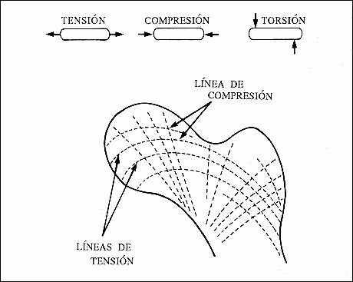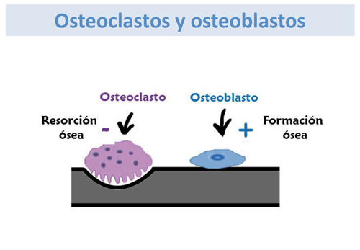In space, in microgravity, this is an abysmally negative trade balance. This ideal nation buys everything it consumes. **Osteoblasts leave their work while osteoclasts eat the bone, reaching 2.5% monthly bone loss.** That's why NASA puts so much emphasis on solving these problems: once past 30 years is very difficult to recover bone mass.

Another very important issue is our muscles. These serve to move large objects, move nimbly and have good mobility, among other uses. We will not explain how the muscular theme works because it is very similar to bone. We leave it to the reader research.

Like any asset of a company, our bones, organs, muscles also consume resources for maintenance it. Bones for example have a period of maximum duration of 10 years, they are renewed every day over a period of disintegration and continuous and constant formation as explained above, which consumes a lot of energy. The same applies to the muscles: By the laws of physics, more specifically by inertia, more energy is required to move muscles with large mass than with small mass, while maintaining living cells. In short, we have 2 active consuming resources and idle state. What would you do...?

What the body would do (and does)

What the body does, as a good business manager notes that there are idle resources that consume energy but do not produce value; they are not holding us; they are not making extreme efforts. After several weeks in the absence of gravity the body interprets this is gone forever and makes the decision: disintegrate muscles periodically to a level deemed necessary and reduce bone mass by about 2.5% on a monthly basis by a deficit, implying that after 20 months the astronauts have lost on average half of their bone mass. The point is that the body does not know that after several months of passage astronauts must return to a g = 9.81 m / s2 and that's when they suffer accidents. They land in a much more difficult to move without the necessary (bone and muscle) infrastructure accidents such as hip fractures or tibia and fibula occur atmosphere. In the best case, the astronauts must make rehabilitation sessions before they can make sudden movements.

As a curious fact, bones are broken and fired through the urine, so biochemists analyze the same NASA astronauts for excessive calcium and obtain these statistics monthly bone loss. The way to analyze it is very particular: the substance is flickers and the light. A light-sensitive sensor, redundant analyzes the visible spectrum and by a predetermined scale, knows how much calcium there because otherwise it reflects the light.

Below is a picture illustrating the bones more worn by this problem and their monthly attrition rate is attached.

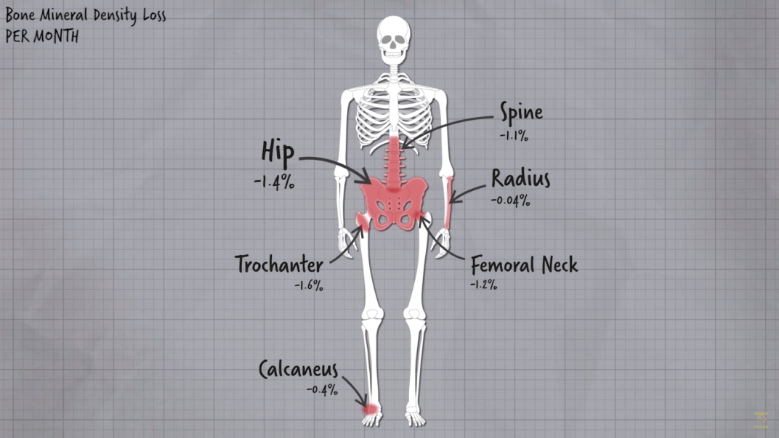

*This is a study by NASA.*

Our project addresses all these areas to eliminate the problem.

Presented the issue and explained its causes, now introduce current solutions.

# Current solutions

Today NASA works with 3 devices on the ISS to combat this problem. They are: The **ARED**; **CEVIS** and the **COLBERT**.

## ARED

The **ARED** (Advance resistive exercise device) is a mechanical device that happened to replace the IRED (Interim exercise resistive device). It works with vacuum technology which absorbs a piston and by a lever creates a pressure that allows us to perform various exercises such as squats, lunges, shoulders exercise and much more.

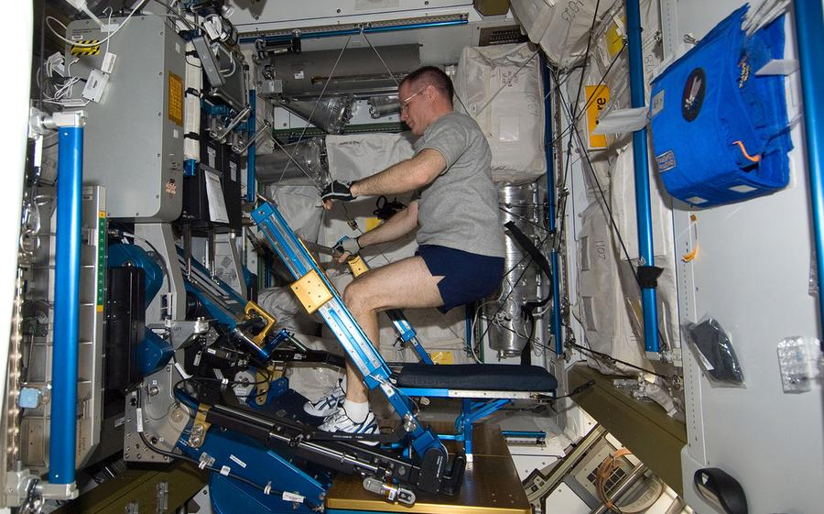

## CEVIS

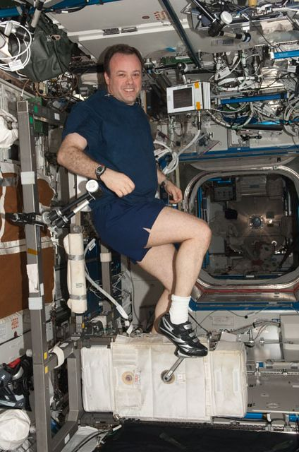The **CEVIS** (Cycle ergometer with vibration isolation and stabilization) is a species of aerospace bicycle allows us to perform cardiovascular training. It is characterized by its "Isolation and Stabilization" system, which allows than our energy is not transferred to the ISS and change address. This machine provides the ability to perform cardiovascular workouts. It is proven empirically and scientifically that cardiovascular workouts are not the most suitable for the generation of muscle: if we see professional cyclists we can see how their performance is independent of muscle mass, rather depends on it and the less you have the better.

On the other hand, we see athletes bodybuilding and extreme force have large muscles and of course who have not developed biking or running on the treadmill is more, these when doing cardiovascular workouts care of their muscles because they suffer the risk of **catabolism** as this training is energy intensive and does not need big muscles to be made so that the body decides that are not needed and transforms them into energy for consumption.

## COLBERT

The **COLBERT** (combined operational load bearing external resistance treadmill) is a kind of treadmill which has aerospace fasteners for the person and thus to generate a kind of force of attraction that allows us to take walks and jogs. Its disadvantages are clear: provides a cardiovascular workout like the CEVIS, which is not necessary for astronauts because they are not Olympic athletes and in addition, each step produces an impact that can damage our joints. What we seek is the stimulation of osteoblasts, no wear of the joints, which is first is achieved by **compression of the bones.**

However, these teams have many general disadvantages to list

**• They are not portable**: They cannot be carried from one place to another, so that training becomes monotonous, uncreative and prevents the possibility of playing astronaut and vary its workout.

**• They are bulky**: These devices occupy a large space that could be used in more elements of research, as well seen in the ISS, where we see notebooks on each side of the modules.

**• Do not allow mobility:** If an astronaut must train with one of these devices, it is bound to remain there; you cannot go from one side to another of the ISS while training which could return the really fun workout if so.

**• Are monotone**: The exercises are almost alienating. Are treated reps, sets, etc. Human beings are naturally reuses these types of exercises and ends forsaking them.

**• time consuming**: to train you have to spend precious time that astronauts can use either continue working or also rest or have more free hours (which serve so that he can pay more when working). Today astronauts exercise 2.5 hours a day. ¡¡It´s too much wasted time!!

Effictron overcomes all these disadvantages and we will explain our project.

# Effictron

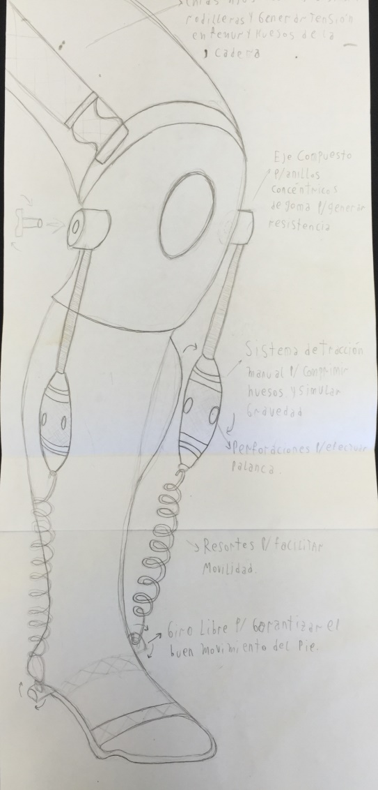

Effictron is a simple exoskeleton than using 3 technologies passively trained astronaut. This means that the astronaut does not need to spend time to train but that their natural movement forced by this suit makes him is in an "atmosphere" a little more like Earth and to perform its tasks at once coaching.

## 3 technologies:

### The 1st Technology: Concentric rings of rubber.

Unlike all robotic and motorized exoskeletons than we know, Effictron has bushings made with concentric rings with rubber surface on the joints which do not assist the user, but rather will generate a difficulty bending them and thereby produce a workout and help with the preservation of muscles.

The rubber is an inexpensive material and excellent both in terms of dynamic friction coefficients. 2 elastic bands brushing against each other by these rings rotation is difficult, quite the opposite to what happens with metal shafts lubricated with oil films.

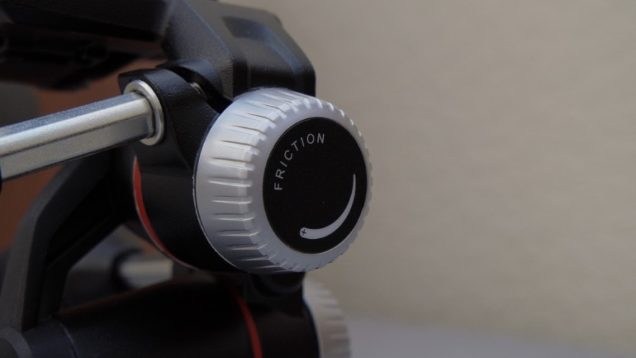For regulating a plastic clamp to turn increases the compression between hub and shaft and physical as well explains the friction force is the friction coefficient of both materials by the normal force (clamp force) is used. As this force can be unlimited, then so it is the regulation and so we get a system where stronger and weaker other people can use it the same device. One suit for all crew.

### The 2nd Technology: Compression bone.

The device as shown in the figure has a template to use the equipment the astronauts being barefoot (something they really enjoy) and not have to force them to use a shoe.

This template is simply fastens with girdles the foot and leg continues for a few more thistles to ensure support. Besides this template has a perforated screw shaft allowing the springs and at the same time give mobility to the heel (calcaneus, one of the most affected by this problem).

With respect to the knee in a knee brace neoprene where the bushings and shafts used. These bushings have an underrun rod which is threaded at its end. It is male thread is inserted into a metal cylinder with well lubricated female that is introduced or expelling turning this rod, depending on the direction of rotation thread.

The interesting thing happens when we connect the cylinder with the spring attached to the template on both sides: a voltage is generated. This tension in the tibia and fibula bones and other involved simulates our body weight by acting on our legs, as in a situation where we stand with usual gravity force. As we saw in the previous picture, here we are attacking the problem of the calcaneus. As the variation stretch minimum spring, it will not change considerably and not have problems of varying forces that break the bones to stretch and do not exert pressure to be contracted (we emphasize this because you as forward we see this if it is a problem in the Upper part of the body).

We continue with the knee brace. For this not to slide down by the force exerted by the pistons, simply this is supported with 3 inelastic straps on a belt which is also part of the exoskeleton and we will discuss. It also affects the hip muscles.

 Here we are attacking the main problem, trochanter, femur and bone wears over in astronauts. You need to apply a lot of pressure to encourage the appearance of osteoblasts. Furthermore we started to attack the problems of the hip and the femoral head that will complement with the 3rd technology.

### The 3rd Technology: Atmospheric pressure.

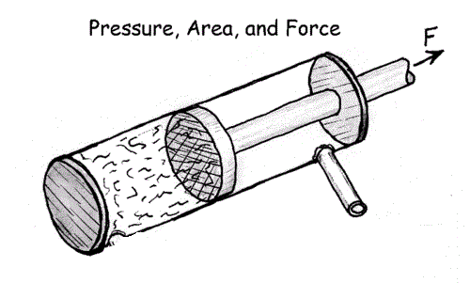To complement compression in the hip and the femoral head design similar to the previous system but thinking that the torso is a part of very mobile body and the astronaut sit, crouch or make various movement can reduce stretch spring or band and modify the applied forces, then we seek to obtain a constant force regardless of the variation of the position of the end of the device (stretching), which does not happen with a spring or with an elastic band and even with a piston if it is not used properly. This constant force allows us to use the suit as a crane, a weight-counterweight system, but instead of being the weight force acting is the atmospheric pressure compresses the piston which makes loading. The weight-counterweight system will use it to perform tilting movements of the torso without making effort (since the purpose is compression, do lumbar and abdominal strength).

 To lean forward should make an effort to decompress the rear pistons with our abs, but the weight-on weight system cancels the moment of force and allows us to move freely. As a summary of this chapter: This system allows us to maintain the compression force resulting in the column, but at the same time nullifies the moment of force produced by fluctuations of the plungers. The front pistons help rear and vice versa.

However the reader may be a little confused because you think how a piston can have a constant force if the atmospheres modified as x varies?

### Analysis of technologies: The Secret of the Void.

*Researching and using the resources provided from Space App to us for this challenge, we solved the problem with ARED technology and this is how it works:*

We all know that the spring force is **F = k * Δx**, where **k** is a spring constant but the variation of x obviously is a variable, our strength is variable. If we want to simulate a constant force we cannot use these instruments because in certain positions would have much strength, and other less stuffy, very little. The same is true with elastic bands. So what can we use to get a constant force, as is the weight and strength such is that the need for **the moment of force is zero** all the time? These two requirements were the problems we had to solve when designing the top of the exoskeleton.

**Thermodynamics** gives us the answer and is the **Piston-Plunger** system applied in the **Void**. According to the laws of thermodynamics that govern gases we know that a gas at 1 atmosphere inside a cylinder is a stationary system. If we threw the piston would pass to an unbalanced system, which when released it return to its initial position. That's what we see in the experiment. Now let's see why it happens:

Ambient external pressure has not changed when releasing the plunger but if the interior is decreased as the constituent particles of this gas are dispersed and the system results in the entry of more particles (or compression thereof). Then we noticed that the piston goes back again and that is because the stronger atmosphere governs the weaker until they are equal. But make no mistake thinking that "power vacuum causes" as previously thought, what happens is that in our atmosphere we feel there is pressure not because it is offset by the 3rd Newton law in all directions. On Earth, there is a pressure throughout the body of 1 atmosphere caused by the weight of the air around us. It may seem funny but if we placed our extended hand up and we said "we are enduring the pressure of 100 kilopondios in our hands" would not be false. What happens is that there is also air beneath our hand exerting a force in the same direction but in the opposite direction and make the effort for us. Our hand is not going to sink in the air nor will fly through the skies, but it will feel and feels like now in all of us, that pressure. We can increase the pressure simply immersing us into the water, the more submerged, the more water we have above and pressure suffer until our diaphragm can no longer overcome such great pressure, making impossible to increase the size of the lungs and thus the breathing (for this reason deep divers use a pressurized suit, it is very interesting to know because we can make an analogy with this technology later). This example shows us that vacuum pressure does not exist, "the vacuum does not absorb". What it happens is than **the vacuum is weak**, and the atmospheric pressure makes it easily give way. When we generate vacuum with a syringe plugging its output and pulling the plunger appears as the necessary force is growing (and actually at first it is), it seems like "an empty makes an incredible force to roll back and return to its original "but it is not. It is having learned that the phenomenon that generates the pressure force is not the lack of pressure then we conclude that **the maximum pressure is the pressure in the outer atmosphere**. What happens when we noticed is the plunger is easier to pull at first explained referring to that there is some air in the cavity, and the pressure there at the start in the closed part is very strong and helps us pull (we can see clearly in the following Free Body Diagram)

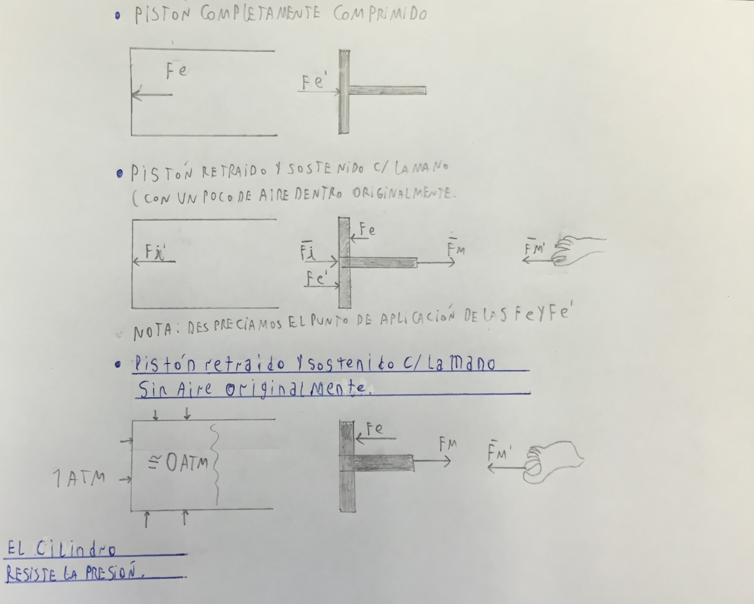

 but as the vacuum is produced this pressure decreases and helps us less to a point where it no longer helps us and reach a maximum force which is constant and is just the strength we need, in other words the cavity to expand It must contain the least amount of air possible because a constant force from zero is ideal, but we can achieve that can become constant very quickly. We can represent graphically as the positive part of the arctangent, which has a horizontal asymptote representing our strength limit. Just this force the piston moves with MRU (in a model where several forces are neglected).

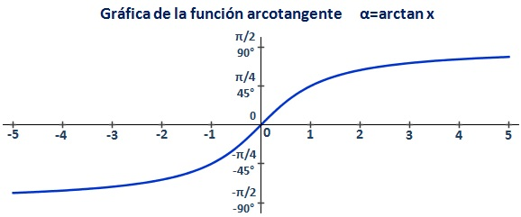

Representación gráfica de un modelo que sirve para representar

la Fuerza en función del volumen.

Clarification: Do not drop the reader into the mistake of thinking that once I reached that maximum force are enabled to create a vacuum with infinite volume. Here starts playing the material and the surface of action of the external pressure on the lack of pressure. Imagine a piston of infinite length: if we achieve the maximum force backdate the plunger does not mean we can go on like this endlessly as the action surface where the pressure is applied increases and so does the moment of force as this is being applied increasingly further from the support points (cap and plunger). This will result in an **implosion** of the cylinder. This is precisely our **natural** **limit**. This implosion is that we must be careful in 2 directions: Mainly in designing a cylinder not implode, which involves choosing the material; thickness; piston area and length among other factors and second **economic** **factor**, we cannot give an excessively large thickness to ensure operation since the materials have a cost and most efficient is always to reach the optimal choice. To achieve this we rely on the **Differential** **Calculus** and **Algebra**.

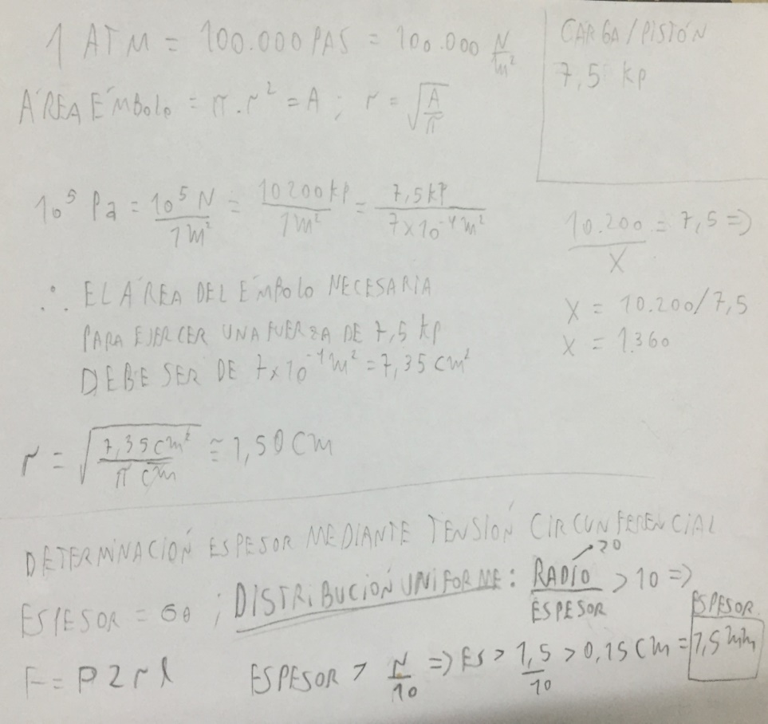

The values ​​obtained for each piston are the following

Inner Diameter: 3cm,

Material: Steel sae 1045

Thickness: 2.6 mm (this data was provided by a mechanic engineer who helped us.)

Admissible Maximum travel: 12 cm

Explained the technology to be used, we turn to implementation.

## Technology implementation in the exoskeleton

## Upper-Part

The main idea is to compress the spine for bone stimulation explained above with other bones in question. Our idea was originally generate tension with the same sets of legs connected at one end to the belt and the other to inextensible belts outfielder style that encircle the neck and connect via "**backpack closures**", compressing the spine and the entire torso, but there were two problems.

On the one hand we realized that unlike the calf, which his movements do not change significantly the spring, the complexity of the torso if we can imagine as an astronaut crouching or bring your knees to your chest for some reason can come from happen to have a spring fully stretched to one tablet. This generates variable forces impeding us, since we cannot get our balance point between all the springs. We do not want to tire the lumbar and abdominal. Come up with a very clear and numerical example so that everyone can understand.

Imagine we have our suit, 8 springs that surround us and compressed. If we are upright, there is no problem. All springs are stretched Δx therefore they produce the same force. Now that happens when astronaut arches her back to look for something that is near his hip. Clearly the front springs are rolled back and back are stretched. The annoying thing about this is that the front springs are not going to order to compensate for the new rear force, since by reducing Δx decreases F = kΔx. And not only decreases. Then every movement outside the central vertical axis, we would have to do a lot of strength to move, as if they were bound astronauts.

Well, with this vacuum technology it does not, per Δx cm pistons, the same amount Δx other roll back pistons will be tract and the force **EVERYONE WILL ALWAYS BE CONSISTENT**. This is what we consider a wonderful thing about this system.

The system uses weight-counterweight of a crane not only 360 but it does in microgravity.

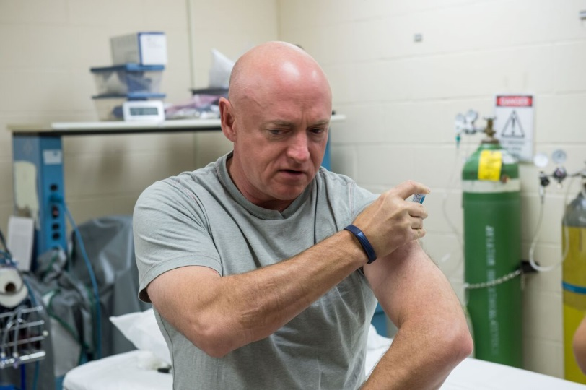8 mini pistons are equally distributed around the waist. The reason for doing many pistons is, first, to have the same results with few, large and cumbersome pistons. Second, it can simply be disconnected and go changing its location to use less and less kilopondius support, in the case of weaker than others. Clearly the belt has more handholds to connect the piston required amount if it is determined that the astronaut needs a heavy burden due to their heavy weight. This vertical compression is also very important for the joints and the body in general, since another astronauts’ problem is the **spontaneous growth**. When they arrive they have grown to 4 or 5 cm in a few months. It seems a benefit but it is not: The separation of the vertebrae and joints due to the absence of pressure on earth then generates great pain. As we describe in your own words and jokes astronaut Scott Kelly:

*"I have so much pain in muscles and joints that could not tell exactly which body part hurts me more"*

*"One issue that gravity took care to put back in place"*

*During the flight to the United States, the astronaut tried to sleep. "Something that was very difficult because I was uncomfortable and had a lot of muscular pain."*

# SOWT analysis

Every project must have a SWOT analysis showing irrefutably concerned of their strengths, opportunities and more importantly his weaknesses and threats:

SWOT are distributed throughout the text, the purpose of this section is to have them bound together for easy access and evaluation.

## Strengths

• **It is efficient**: as mentioned in the economic section: the level of training is 3 times more intensive, using only just over 5% of the time required for other machines.

• **It is small and light**: This gives us the advantage of portability to any module and train wherever we want.

## Opportunities

• We saw that takes up very little space, great opportunity to also be used on trips to the Red Planet.

• It has a great future ahead regarding development and can automate processes and make large sensor-actuator systems.

• You can really become a development project which will help mankind in some way

• You can develop a system of packaging and shipping to be portable and takes up very little room.

## Weaknesses

• Today it is just an idea that seeks to be a prototype. It will go through large empirical adjustments needed to be able to become something useful for astronauts.

• It can become too uncomfortable for astronauts, it is something we should evaluate with them.

## Threats

• A major concern we have is the burden on the back. We believe it can be harmful if not applied correctly. Be especially careful

• A possible mechanization of the exoskeleton can cause lack of control of it and hurt a crew member.

# Using Effictron, a glimpse into the economy

Effictron is designed to be different from other machines. It is not a training tool. Effictron is an exoskeleton that used in astronaut international space station about 3 times per day, all day can rest for 40 minutes 1 time for relaxation and leisure activities.

Effictron, as not to prevent the mobilization of astronauts throughout the ISS, they can devote all their time to repair, investigate and bring the tasks to be while train their muscles and bones. Know the reader astronauts work 2.5 hours per day only for the maintenance of your bones and muscles, which is not enough and the loss still exists. Effictron demand only 3 days a week, about 5 minutes placement and misplacement (once the astronaut has taken the skill), with an intermediate pause have a total of 20 minutes a day. In terms of week, special training sheds some 17.5 hours lost in training, while demand Effictron only 1 hour a week! If we add, knowing that astronauts would wear the suit 15 hours per day, ie about 45 hours a week, we realize that we exercise the muscles 3 times more than before. In addition we are again giving to the astronaut exercise quality because, in order to prevent these musculoskeletal problems, NASA demand daily exercises, which we consider incorrect because the muscle needs recovery days: if you train him day after day the only thing is overtraining occurs leading to **catabolism**. With Effictron this problem is solved because the astronaut is between 2 and 3 days to rest and regenerate their muscles. **We are very confident that astronauts using Effictron not only will stop their muscle loss but that will increase it significantly**.

# Effictron humanitarian sense

Effictron is a simple project, but also supports a highly complex because it encompasses too many science knowledge. We strongly believe that the development of this product will become solutions for the human race in the treatment of diseases such as osteoporosis, muscle problems and growth; and we realize them as we ourselves have become very knowledgeable thanks to the opportunity that NASA has given us to develop our potential. We have learned and developed chemistry; Physical; physiognomy; Pneumatics, mechanics, logic, mathematics, medicine, physical education, drawing and many others. We all know that most great inventions arise from **the U.S.** **army** and **NASA,** and developing Effictron confident that we can contribute our grain of sand to the world with a spontaneous discovery that can be applied to the surface of planet earth.

# Placing Effictron

The placement procedure is as it follows:

1. We put the kneepads

2. We adjust the bands that secure the axes at the sides of the knee.

3. We screw the threaded rods on the axis of the knee.

4. We position the template on the feet and adjust the straps.

5. We screw springs in the side holes of the template

6. We join springs and threaded rods giving only a few laps

7. We put the belt.

8. We hold the knee to the belt with well strained inelastic ribbons.

9. We started to rotate the cylinder until stiff.

10. We put the pads and pistons hooked to the straps.

11. Buckled with "backpack closures" behind his head.

12. One by one, so equispaced, we placed the pistons on the belt.

13. As we place we will go feeling the strain on the shoulders; observe how the pistons are retracted. Regardless of how many kilopondius represents each piston and use the load on each astronaut indicated by the medical team.

14. As the pistons installed, we readjusted with the corresponding tool lever cylinders anklets, so that the knee does not rise or take pressure in the wrong places.

15. The suit is ready to use.

Extra exercise

If some astronauts would use Effictron in their spare time because they want to increase their muscle mass in addition to scientific work, they can. On the other hand, if there is any astronaut who has facility to lose muscle mass by genetic issues it can also be used Effictron to exercise itself.

Following is different workout routines for who is enjoying this or you need it and thus enhance the performance of Effictron.

On the same day can be 1 to 2 working muscles. It is extremely important to rest the muscle to run 48 to 72 hours to be regenerated. It is a serious mistake to force the muscle while it is in its restructuring process.

## Soleus

Work of soleus. The soleus muscle is in charge of the mobility of the foot. It is very useful to protect the tibia and fibula of different injuries.

To train with Effictron simply suspended in the air we raise the toes. This movement down the heel and oppose the spring tension, exercising muscle.

*3 sets x 12 reps.*

## Hamstrings and quadriceps

To work the hamstrings and hamstrings, simply we use the technology of concentric rubber rings. To bring your heel toward your buttocks will train the femoral and regulating the handles, intensify or diminish the friction load.

The hamstring cramp is one of the most unpleasant because they generate a lock that does not allow us to stretch the leg and can be traumatic, so it is recommended intensely stretching those muscles well after working them and they do not use excessive friction. Past 2 months of training new astronaut can start up the burden of this exercise.

On the other hand, when the astronaut´s leg up will be congesting the quadriceps. Both muscles are very important as they are those containing at Femur bone decalcification more on this issue.

*3 sets x 8 reps*

## Adductors

Adductors will train with your legs extended. The scissor open, friendly exoskeleton movement, and bring back inward (closing the scissors) against the springs. Regarding cramps, again the same as for femoral. The abductors are muscles that can withstand heavy load, but it is one of what should more heated, so it is always recommended that, by level of experience you have, the abductors should start work without Effictron, and since the 5 minutes to start using it and even add great burden on the same day, but it must be gradual and from a near-zero. We do not want the astronauts feel scared and leave the training.

*1 set x 6 reps + 1 x 8 + 1 x 10 + 1 x 12*

## Lower back

Lumbar be worked as follows: It will, depending on the desired level of resistance, less pistons in the back of the belt in front part. For experienced coaches, they can use up to 8 pistons in the front of the belt and so lift the torso, lumbar congesting.

*4 Series 15 Repetitions*

## Abdominals

They perform abdominal lumbar opposite work, so the procedure is the same but reversed. We put the pistons in the back of the belt and try to go forward, as if we were an L in the air while curve us.

*4 Series 15 Repetitions*

## Trapeze

With a special device that comes bundled with Effictron, astronauts can train all trapezoidal area and the sternocleidomastoid, along with other muscles of the neck and back.

Just connect the rear pistons to the mesh head, get it in it and try to touch your chin to your chest. You can make oblique movements for greater stimulation.

*4 Series 20 Repetitions*

*Note: cramps may occur in the throat the first days of training. To neutralize immediately pressed Cramp in the fingers, as if we were taking the pulse, and turn away chest chin as far as possible, pulling his head back.*

## Pushups

Effictron to be detachable parts, astronauts can use cylinders as a training tool, addition them gripping the bars of the ISS and tract them.

To work the pectorals we will connect the pistons to bars opposite grip on the cabin ISS shaped chain, we will take the ends and we will try to join them, as if we connect a tense extra time and we had to do a lot force. Once contact is made, slowly we open arms, always with a slight bend in the elbows to the starting position. The advantage of this system is that when we simulate the constant force dumbbells who want to hit the ground. Imagine that springs this would be impossible because when these are very stretched be impossible to make contact, and when we decompressing, the spring force will be very weak.

*3 sets of 12 repetitions*

## Biceps

The biceps are trained in the same way as the pectorals, but exercise is somewhat different. The arms remain the starting address, i.e., a T: Fully stretched sideways, as if we made a cross. Now what we do is try to attach those wires back, while retaining the position in space elbow. What we do is bring fists to his chest and back to the starting position.

*3 sets of 12 repetitions*

## Back

Back to work we will connect pistons to the bars again but let's grab inverted, i.e. the left with the right hand and vice versa. Again as if we were a scissor hands together, we can even go further, to the full extent of the pistons. Then back to the starting position.

3 sets of 12 repetitions

## Triceps

We work the triceps much like back: Let's take the pistons with a cross grip and then we will make the scissors position, with the difference that our elbows should always be in contact (can be separated when the end of the bending). Then back to the starting position.

*3 sets of 12 repetitions*

## Calves

To work the twins we lean against a wall of the ISS and we held onto the safety bars: place the grip cylinder in a foot at the metatarsal and try to stretch these first moving the toes by flexing the ankle, i.e. "we tiptoe" in the air. Do not worry about the little path exercise, this muscle works in this way.

## Rest of the muscles

With these routines mentioned all the muscles working, as each exercise represents the most congested muscle, but they all work at least five muscles and exercises are those remaining to mention. For example Hamstrings Quadriceps-exercise also works the glutes, adductors, abductors internal rough, etc.

The forearms are working around back exercises and trapezius, biceps and triceps.

# Planning and the future projects.

## Enhancements of the own exoskeleton

Effictron can develop much more than what we see in this report; this is its first mechanopneumatic version. It can be developed in conjunction with the module to be used for the trip to Mars. It is known that the trip to Mars can last at least 3 years, which would imply a huge problem if the exercise of astronauts is not controlled. Effictron can be very useful since the **Marciano** module will not be as spacious as the **ISS**; this implies that the current machines will not work for this project. Effictron does not require all this space astronaut can train just staying where it is.

We know we can develop the best exoskeleton that exists and we trust in our creativity and desire to work. This is just the beginning we would like to achieve technological and financial support to develop Effictron at its splendor.

## Full mesh body for exercise

The purpose of this suit is **complement to the exoskeleton** detailed above, benefiting both the maintenance of hygiene and health of the astronaut corps during routine exercise and, ultimately, while staying off the planet in time longer possible.

Remember that the human body is adapted to the atmosphere of our planet. In areas of low gravity it reacts differently. A first consequence as already mentioned, is the deficiency of bone and muscle laxation. Another consequence, not least, is the **unequal distribution of body fluids** (such as blood, lymph and / or cerebrospinal fluid) throughout the volume of the body, causing fluid overload in some areas of this (upper chest and head), and decreased in other fluids such as limbs. If this situation is not treated properly astronaut suffer from some kind of physiological disorder to reach Earth as changing blood pressure, arrhythmias or stroke (both by lack of blood pumped by the heart), stroke, vision problems. In most of the time, are treatable and temporary cases because the astronaut only spends a few months away from Earth, but if it is **interplanetary travel** or situations that require long periods of time in space these changes systemic will occur longer and very probably bring permanent consequences.

## Fabrics "smart" at the service of human health

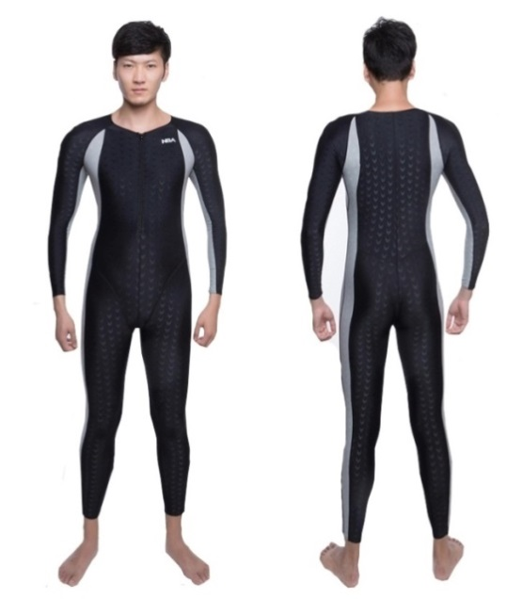Nanotechnology has strongly influenced the **design of more suitable textiles for sport**. Thus have developed fresher and lighter fibers, adaptable to the anatomy of people that facilitates the supply of oxygen to the body and prevent odors. Many of these fabrics are produced with nanomaterials. In swimming, there are "smart" suits than protect from ultraviolet rays and repels moisture. In athletics, plus garments Dri-Fit (which absorb moisture and spread over a wide area to be quickly evaporate) nanotechnology has allowed the emergence of a lightweight shoe: a major achievement has been to develop shoes that weigh no more than 150 grams.

There are multiple disciplines that are favored by this technology, such as medicine, engineering, computer science, mechanics, physics or chemistry, among many others. On the environment, for example, applications of nanotechnology allow the development of clean processes and clean energy. Nanomedicine, while allowing transport drugs to specific areas of the body. In agriculture, pesticides and soils are improved, and construction lighter materials are developed. In the textile industry, meanwhile, nanotechnology enables the development of fabrics that repel stains and not get dirty, and the incorporation of nanochips for temperature control.

They have recently been developed various types of fabric made various polymers and which are made so that they can hold between their tissue capsules with various drugs, such as analgesics, vitamins and nutrients to sustain skin elasticity, that upon contact with changes in body and / or the pH of sweat temperature, these capsules release their contents so they are absorbed thru the skin.

Between these types of fabric, there is one developed in the **NanoMyP** Institute, at the University of Granada, which are already developing an industrial scale. It is also the case of the company **Protela** based in Brazil that developed fabrics with microcapsules that release essential oils like menthol, which give a sense of freshness and / or mucilage of Aloe Vera, whose antiseptic, anti-fungal, healing and regenerating the skin they have made pioneer in the market for textiles. A special case is **Rhodia**, also Brazilian, producing a special type of fabric known as **Emana 66**, a derivative of Nylon fiber **increasing** **microcirculation** and elasticity of human dermis, upon contact with the skin. All these to avoid the appearance of cellulite and **reduce muscle fatigue during exercise**. For all these reasons, we recommend its use for the entire time the body to experience weightlessness. The picture shows a prototype suit made with Emana 66, produced by the company Rhodia.

For our prototype exoskeleton it is important to incorporate a mesh shim Length, formed by wires Emana 66 to improve microcirculation and elasticity of human dermis (skin tissue beneath the epidermis), with microsensors capable of detecting changes in temperature, pH and acidity of sweat, which will produce degradation of capsules of antibiotic (to control the proliferation of bacteria), antifungals (same for fungi), antioxidants (to prevent the formation of free radicals and fatty liver), vitamins and minerals (nutrients and energy for the body), menthol (to give a sensation of freshness as well as a mild antiseptic action) and releasing compounds with O2, water and fragrances, particularly in areas of the body where usual for the presence of odor and discharge.

## Supplementation with other challenges

The psychological effects of living in space have not been clearly analyzed, but there are terrestrial analogies, such as research stations in the Arctic and submarines. Large amounts of stress on the crew, along with the body's adaptation to environmental changes, can result in anxiety, insomnia and depression.

There is considerable evidence that physiological stress factors are among the most important impediments to the optimal performance of the crew. Cosmonaut **Valery Ryumin**, twice Hero of the Soviet Union, cited a passage from *The Handbook of Hymen* by O. Henry in his autobiography about the mission of Salyut 6: "If you want to instigate the art of murder, enclose only two men in a walk-in eighteen by six meters cabin for one month. Human nature cannot stand it. "

NASA's interest in the physiological stress caused by space travel started at the beginning of manned missions was revived when astronauts joined the cosmonauts of the Russian space station **MIR**. Common sources of stress in the first American missions included maintaining high performance supporting public scrutiny and isolation from family and friends. In the **ISS**, isolation is still cause stress.

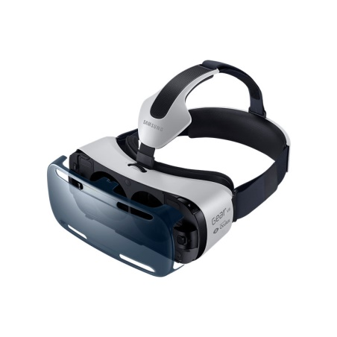A **virtual reality system** is an interactive database can create a simulation that involves all the senses, generated by a computer, searchable, viewable and manipulable in "real time" in the form of digital images and sounds, giving the feeling of presence in the computing environment. The more senses are involved it, more intensity is the simulated experience. Or should we say lived? There are authors seem to suggest so when multisensory warn that digital simulation can enhance the risk of loss of the notion of reality, "giving a pseudopalpable and pseudoconcret character and imaginary entities" (Quéau 1995: 41). Or when you define a virtual reality system as a world despite having no physical reality is able to give the user through proper stimulation of the sensory system, the perfect impression of being in interaction with the physical world (Coiffet 1995: 14). Thus, for Biocca and Levy (1995: 17) the objective of a virtual reality interface is to "complete immersion of human sensorimotor channels in a computer-generated life experience". An extension of the senses through which we can learn or do something with the reality that we could not do before. A technique that also allows perceive abstract ideas and processes for which there are no physical models or previous representations.

The objective of this form of training is to leave behind the reality of outer space and dive into the animation and music to get a better workout. A sporting experience is based on visual cues rather than counting repetitions.

A system to be considered virtual reality should be able to digitally generate a three-dimensional environment in which the astronaut sits present and which can interact intuitively and in "real time" with the objects found within it.

Of all the above attributes, the sense of presence and interactivity are the most important and distinguishing immaterial realities of other systems simulation and computer aided design.

Thus running routine becomes surreal scenarios. This is achieved with music, visual effects and multi-sensory coordination required maximum attention, which allows the body to adapt to work more orders. In the picture we see a virtual reality helmet brand Samsung Gear VR. It provides an angle of 270 ° of any possible scenario.

# Bibliography:

Imágenes: <http://static1.squarespace.com/static/5596f919e4b06639d23f7c47/t/55da0925e4b0c918786af7d2/1440352568774/>

<http://www.nasa.gov/sites/default/files/thumbnails/image/czrn07evmjflw1vp9gm1nq9xslowz9u8axko6mrolli.jpg>

<https://wiki.pierobotics.org/wiki/w/images/thumb/d/d4/Piston.gif/500px-Piston.gif>